BRAIN TUMOR DETECTION USING HYBRID QUANTUM NEURAL NETWORKS

A PROJECT REPORT

*Submitted by*

*ABHINAV TRIPATHI(RA2211026010438)*

*BRIJESH J(RA2211026010443)*

*PRAKASH(RA2211026010517)*

*Under the Guidance of*



*Dr. S. Nalini*

*in partial fulfillment of the requirements for the degree of*

BACHELOR OF TECHNOLOGY

in

COMPUTER SCIENCE ENGINEERING



DEPARTMENT OF COMPUTING TECHNOLOGIES COLLEGE OF ENGINEERING AND TECHNOLOGY SRM INSTITUTE OF SCIENCE AND TECHNOLOGY KATTANKULATHUR- 603 203

NOVEMBER 2024

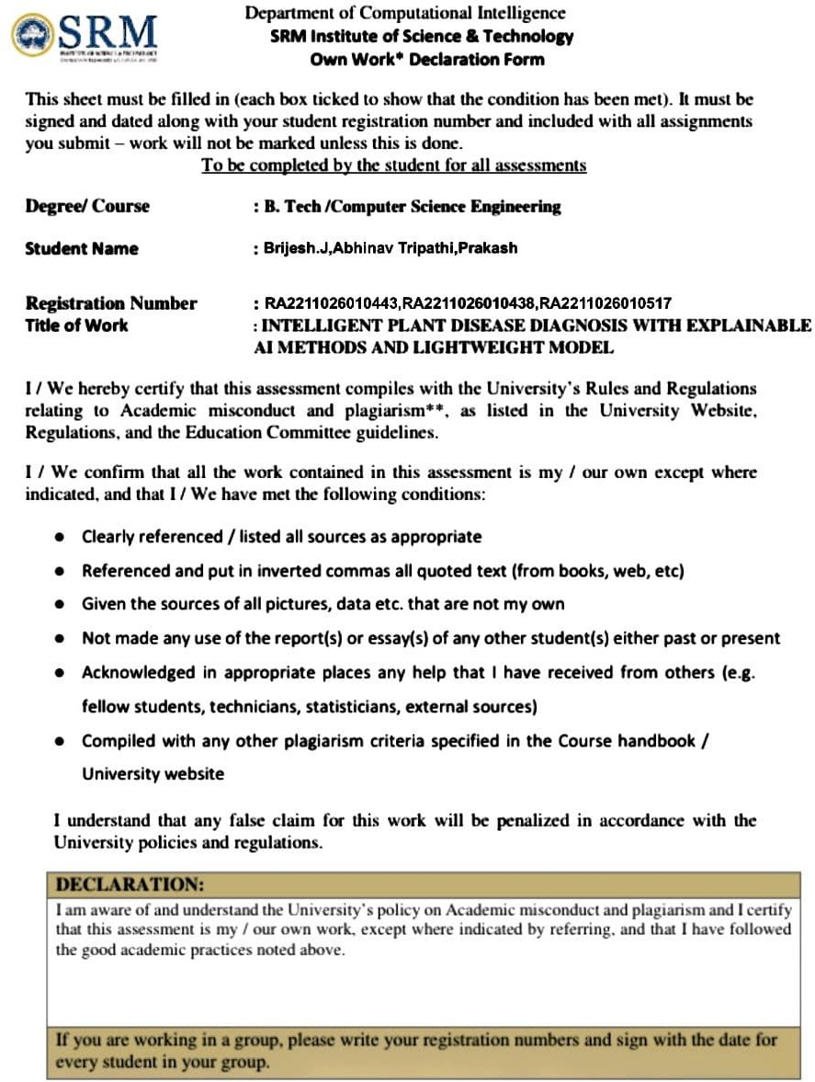

SRM INSTITUTE OF SCIENCE AND TECHNOLOGY KATTANKULATHUR – 603 203

BONAFIDE CERTIFICATE

Certified that 21CSE307J - Mini Project report titled "**BRAIN TUMOR DETECTION USING HYBRID QUANTUM NEURAL NETWORKS**" is the bonafide work of “**AKASH CHINTALURI [RA2211003011525], ANISH SHAMSUNDAR [RA2211003011525], SANYA RAJ[RA2211003011186]**” who carried out the project work under my supervision. Certified further, that to the best of my knowledge the work reported herein does not form any other project report or dissertation on the basis of which a degree or award was conferred on an earlier occasion on this or any other candidate.

SIGNATURE SIGNATURE

Dr. S Nalini Dr. Annie Uthra

|  |  |
| --- | --- |
| SUPERVISOR  Assistant Professor  Department of Computing Technologies | PROFESSOR & HEAD  Department of CINTEL |

**ACKNOWLEDGEMENTS**

We express our humble gratitude to **Dr. C. Muthamizhchelvan**, Vice-Chancellor, SRM Institute of Science and Technology, for the facilities extended for the project work and his continued support.

We extend our sincere thanks to **Dr. T. V. Gopal,** Dean-CET, SRM Institute of Science and Technology, for his invaluable support.

We wish to thank **Dr. Revathi Venkataraman**, Professor and Chairperson, School of Computing, SRM Institute of Science and Technology, for her support throughout the project work.

We encompass our sincere thanks to, **Dr. M. Pushpalatha**, Professor and Associate Chairperson, School of Computing and **Dr. C. Lakshmi,** Professor and Associate Chairperson, School of Computing, SRM Institute of Science and Technology, for their invaluable support.

We are incredibly grateful to our Head of the Department, **Dr. G. Niranjana**, Professor, Department of Computing Technologies, SRM Institute of Science and Technology, for her suggestions and encouragement at all the stages of the project work.

Our inexpressible respect and thanks to our guide, Dr.S. Nalini , Department of Computing Technologies,

S.R.M Institute of Science and Technology, for providing us with an opportunity to pursue our project under her mentorship. She provided us with the freedom and support to explore the research topics of our interest. Her passion for solving problems and making a difference in the world has always been inspiring.

We sincerely thank all the staff and students of Computing Technologies, School of Computing, S.R.M Institute of Science and Technology, for their help during our project. Finally, we would like to thank our parents, family members, and friends for their unconditional love, constant support and encouragement

TABLE OF CONTENT

ABSTRACT 1

ARCHITECTURE OF ALGORITHM 2

STEPS TO IMPLEMENT THE MODEL 3

* **INTRODUCTION**

In recent years, the rapid growth in energy demands, coupled with environmental concerns and resource limitations, has made energy efficiency a top priority across various sectors. Traditional machine learning (ML) methods have already demonstrated significant potential in enhancing energy efficiency by optimizing processes, predicting energy demands, and improving the management of energy resources. However, classical ML approaches are often limited by the sheer computational power needed to handle large-scale and complex datasets, particularly in real-time applications. This is where Quantum Machine Learning (QML) – the integration of quantum computing and machine learning techniques – emerges as a transformative approach. With the power of quantum computation, QML can address these limitations and unlock new levels of efficiency in energy optimization.

Quantum computing operates on the principles of quantum mechanics, allowing it to process information in fundamentally new ways compared to classical computers. While classical computers use bits as units of information, quantum computers use *qubits*, which can represent multiple states simultaneously due to the principles of superposition and entanglement. This capability allows quantum algorithms to handle exponentially larger datasets and solve complex optimization problems faster and more efficiently. For energy efficiency applications, this means that QML can improve optimization processes, streamline resource allocation, and enable more precise and dynamic responses to fluctuating energy demands.

One of the primary applications of QML in energy efficiency optimization is in grid management and smart energy distribution. For instance, balancing the supply and demand in power grids, especially with the growing integration of renewable energy sources, presents a challenging optimization problem that classical approaches struggle to solve in real-time. QML models, however, can analyze vast amounts of real-time data, forecast demand and generation patterns, and make rapid adjustments to distribution, minimizing waste and maximizing energy utilization. This can lead to significant savings in energy costs and reductions in carbon emissions, addressing both economic and environmental concerns.

Furthermore, QML can enhance energy efficiency in industries through the optimization of industrial processes, such as in manufacturing, transportation, and logistics. By using quantum-enhanced ML algorithms, industries can optimize process parameters, reduce energy losses, and improve overall operational efficiency. Quantum machine learning can also aid in the development of more energy-efficient materials by accelerating the discovery process of materials with specific energy-related properties, such as superconductors or energy storage materials, which are critical for creating more sustainable energy solutions.

In summary, quantum machine learning has the potential to revolutionize energy efficiency optimization by leveraging quantum computational power to tackle problems beyond the reach of classical methods. By enabling faster, more accurate, and more comprehensive analyses, QML can help societies transition towards more sustainable energy systems and reduce the environmental impact of energy consumption. As the field of QML continues to evolve, its applications in energy efficiency are likely to expand, offering transformative possibilities for the future of energy management and sustainability.

* **LITERATURE REVIEW**

Quantum Machine Learning (QML) has gained significant attention for its potential in enhancing energy efficiency optimization across various domains. The convergence of quantum computing and machine learning has opened pathways to tackle complex energy optimization problems that were previously infeasible with classical methods. The literature outlines several key areas where QML can be particularly impactful: grid management, industrial process optimization, and the development of energy-efficient materials.

1. **Grid and Resource Management**: Studies show that QML algorithms are effective in optimizing grid management, especially in balancing supply and demand, as they can process vast amounts of real-time data to make instantaneous adjustments. For instance, QML models are applied to improve energy efficiency in smart grid systems by rapidly analyzing and forecasting demand patterns to minimize waste and optimize resource allocation​.
2. **Optimization in Industrial Applications**: QML has also demonstrated potential in optimizing energy-intensive industrial processes. Applications of quantum-enhanced reinforcement learning in fields such as manufacturing and logistics have shown that quantum algorithms can adjust process parameters dynamically, reducing energy waste and improving efficiency.
3. **Development of Energy-Efficient Materials**: Research highlights how QML assists in the discovery and design of materials with high energy efficiency, such as superconductors and better energy storage materials. These materials are vital for sustainable energy solutions, and quantum algorithms accelerate the exploration process by quickly navigating complex chemical spaces​

In summary, QML’s ability to handle complex datasets and perform optimizations at scale positions it as a transformative tool for energy efficiency across multiple sectors. As research advances, we are likely to see QML’s applications expand, pushing the boundaries of what is achievable in sustainable energy solutions.

## **Abstract**

Creating an energy efficiency calculator using quantum machine learning involves a combination of quantum computing algorithms and classical machine learning techniques.

Energy efficiency calculations can involve many variables depending on the system (e.g.,

buildings, electronics, or transportation). Some key factors include:

* Power consumption
* Heat dissipation
* Operating conditions (temperature, voltage, etc.)
* External environmental factors

For the quantum machine learning (QML) approach, the goal is to optimize energy consumption by predicting the most efficient operating parameters based on historical data.

## **Architecture of Algorithm**

1. **Data Preprocessing** (Classical):
   1. Classical computations are performed to prepare the input parameters, such as configuring the quantum circuit based on the data.

#### Parameterized Quantum Circuit (PQC) Setup (Quantum):

* 1. The quantum circuit is constructed with parameterized gates, designed to represent the optimization problem.
  2. The parameters are initialized, and the circuit is executed on a quantum device or simulator.

#### Optimization Loop:

* 1. **Quantum Step**: The quantum circuit is executed multiple times (shots) to gather measurement data, which is used to estimate the cost

function.

* 1. **Classical Step**: A classical optimizer (e.g., gradient descent, SPSA) is used to update the parameters based on the cost function's gradient.

1. **Feedback and Parameter Update** (Hybrid):
   1. Feedback from the classical optimizer is used to adjust the parameters of the quantum circuit.
   2. Depending on the optimization technique (e.g., QN-GD, Rosalin), adjustments are made to improve energy efficiency by reducing the number of shots or adjusting the learning rate.
2. **Error Mitigation** (Quantum):
   1. Techniques such as Zero Noise Extrapolation (ZNE) are applied to reduce errors in the quantum computation, improving both accuracy and energy efficiency.

#### Convergence Check:

* 1. The algorithm checks if the cost function has converged. If not, the optimization loop is repeated with updated parameters.

This architecture leverages the strengths of both quantum and classical computing in a hybrid approach, ensuring that the computational load is distributed optimally while focusing on minimizing energy consumption.

# **Steps to Implement the model**

### Simultaneous Perturbation Stochastic Approximation (SPSA)

**Why it's important**: SPSA allows for optimizing energy consumption using stochastic gradients with fewer

evaluations than traditional methods, leading to lower computational energy usage.

### Frugal Shot Optimization (Rosalin)

**Why it's important**: Rosalin is highlighted as a technique that significantly reduces the number of circuit executions (shots), leading to 20x improvements in energy efficiency. This is crucial in energy systems that require repeated evaluation of different configurations.

### Error Mitigation Using Zero Noise Extrapolation (ZNE)

**Why it's important**: Error mitigation techniques like ZNE allow quantum devices to perform more accurate calculations while consuming less energy in the long run. Without ZNE, noisy quantum calculations could lead to suboptimal energy solutions that consume more resources.

### Quantum Approximate Optimization Algorithm (QAOA)

**QAOA** is a **hybrid quantum-classical algorithm** designed to solve combinatorial optimization problems. It's especially well-suited for problems like **Max-Cut**, **vehicle routing**, **load balancing**, and **scheduling**, which can also have applications in energy efficiency optimization, such as **smart grid load optimization** or **minimizing energy costs in data centers**.

* **CODE**

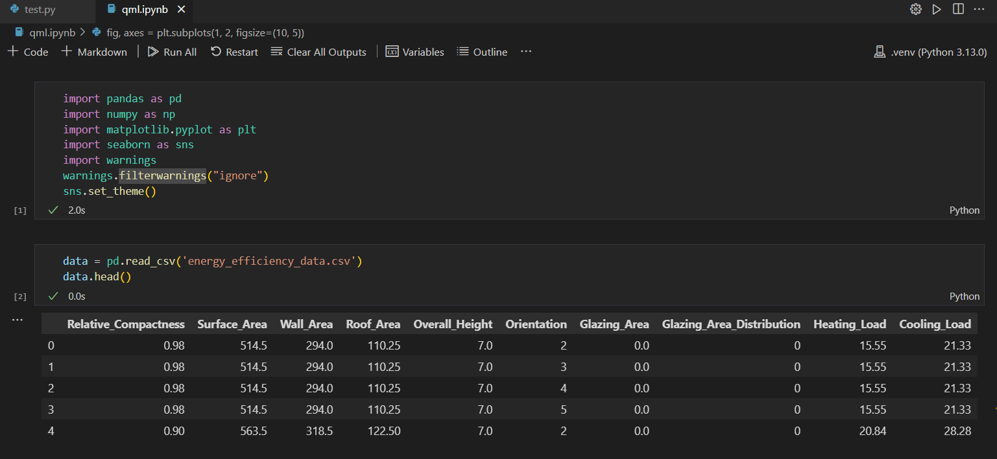

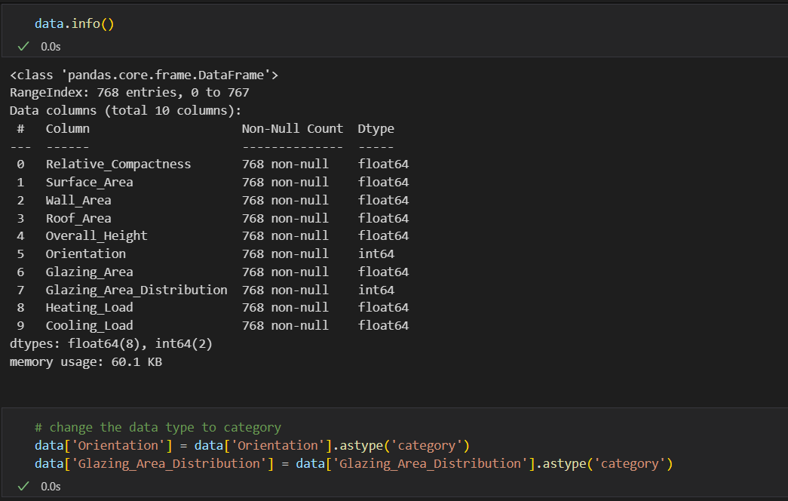

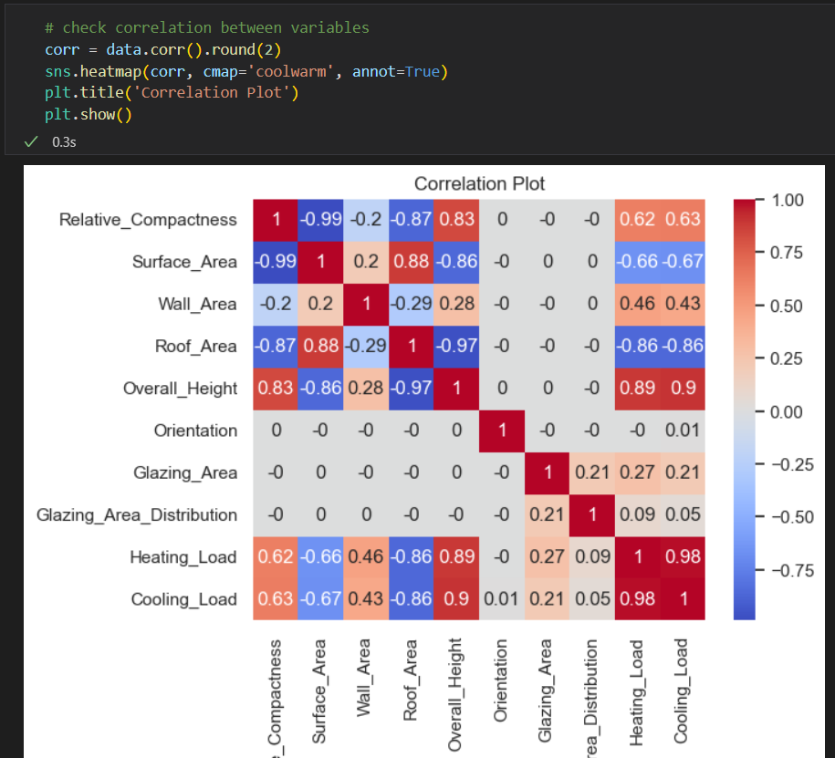

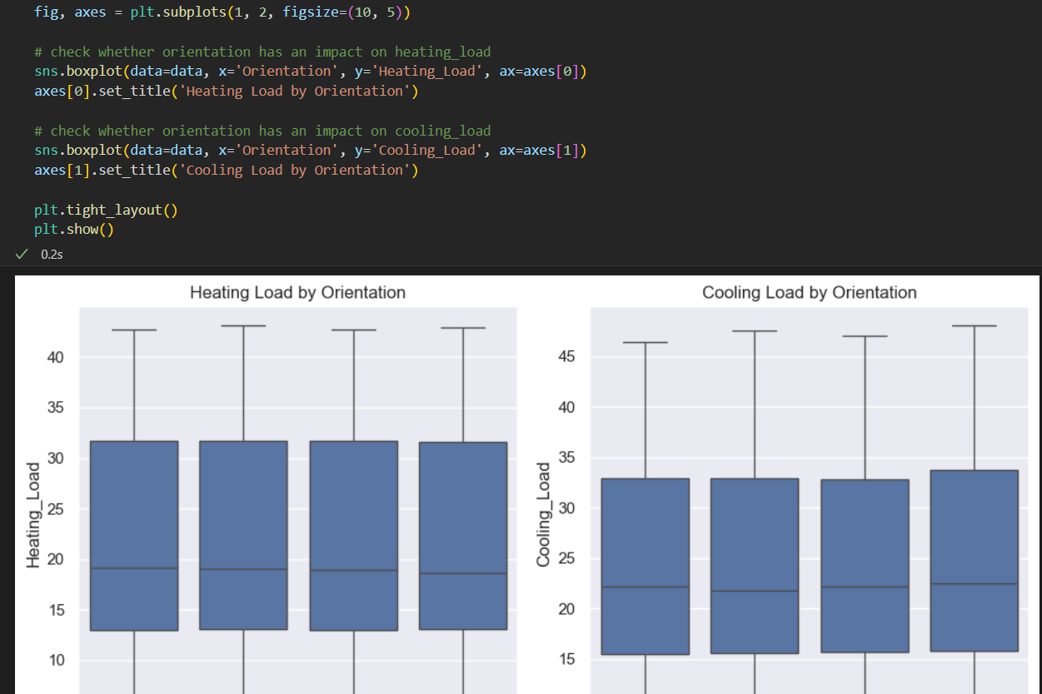

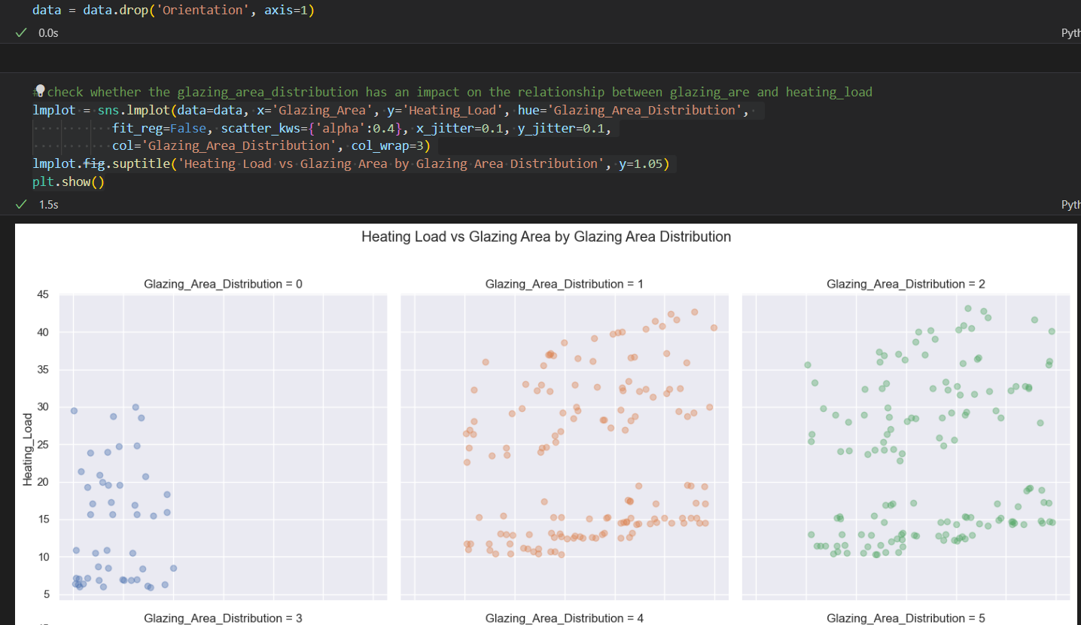

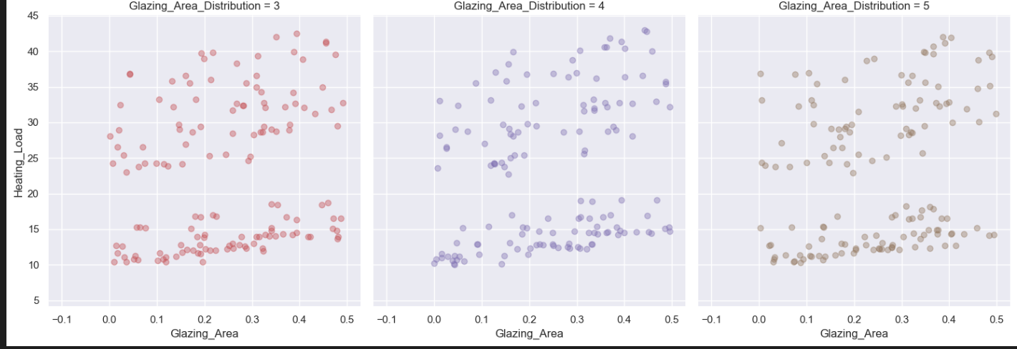

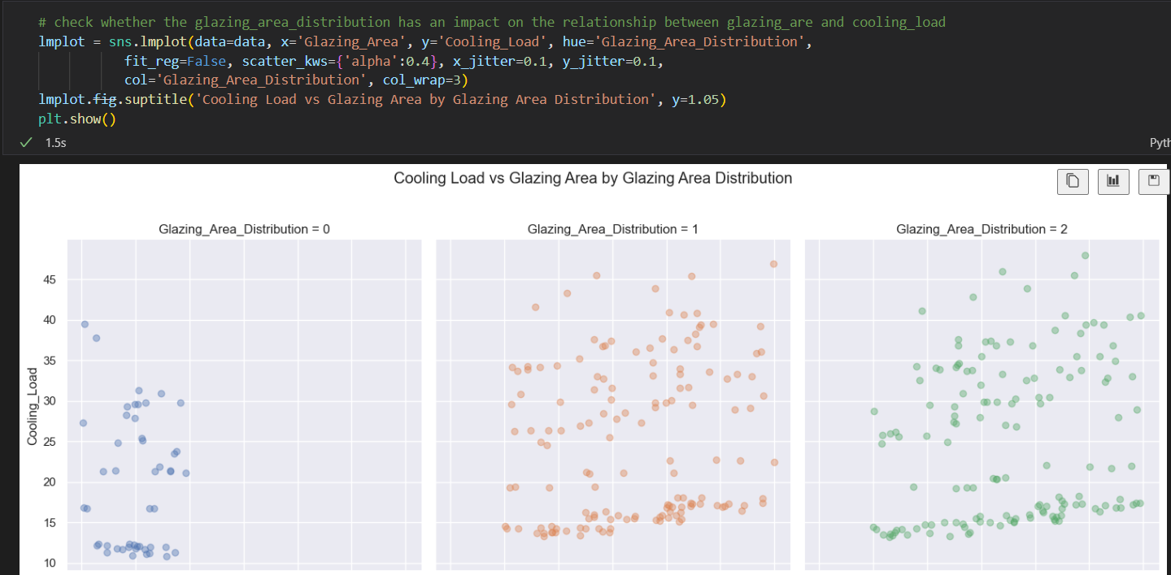

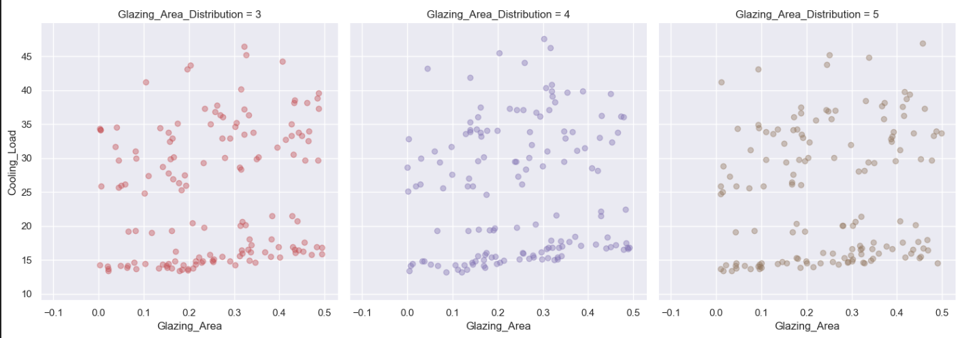

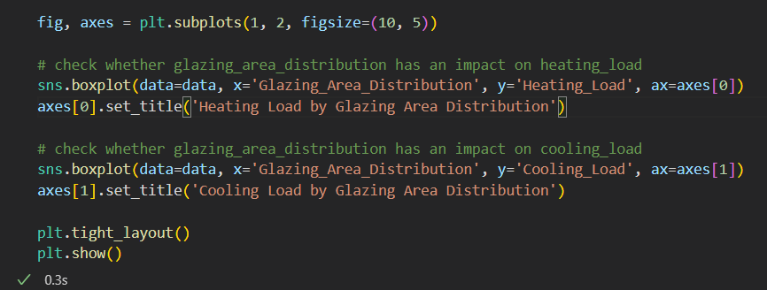

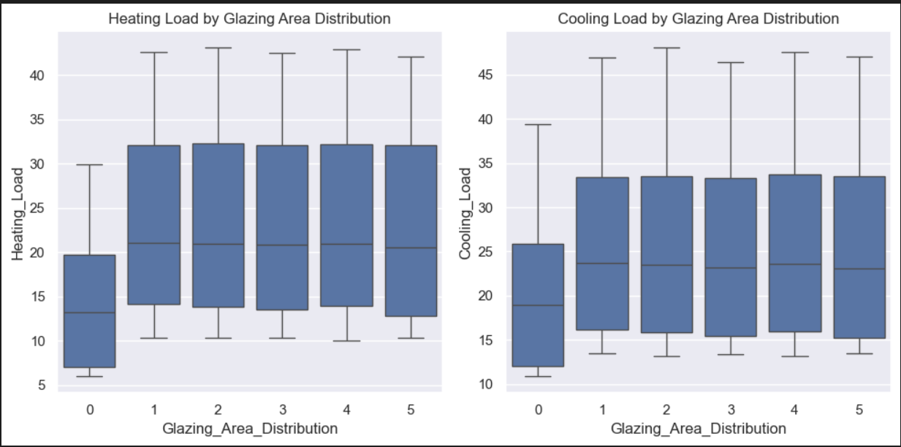

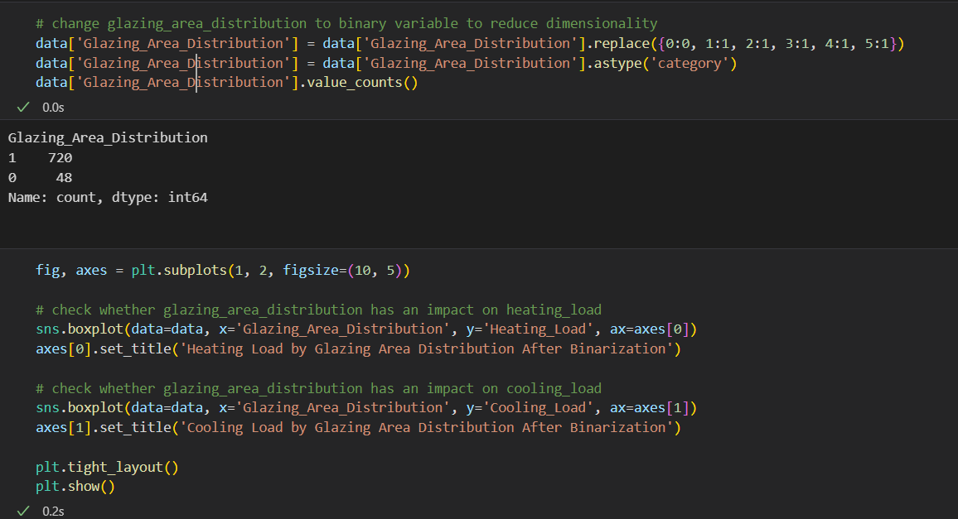

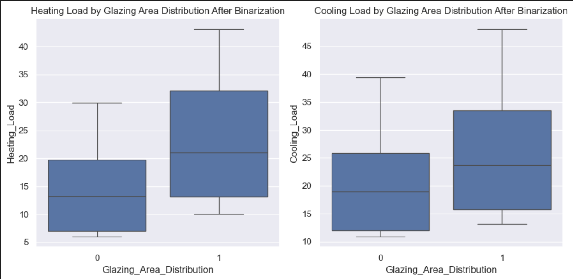

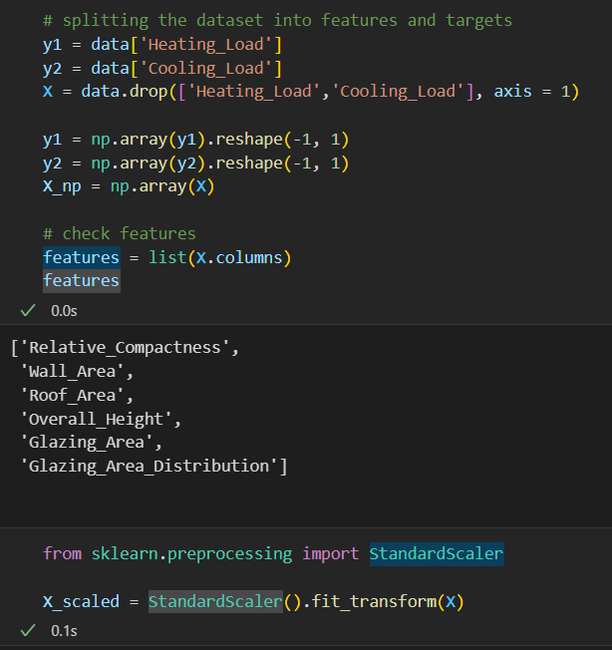

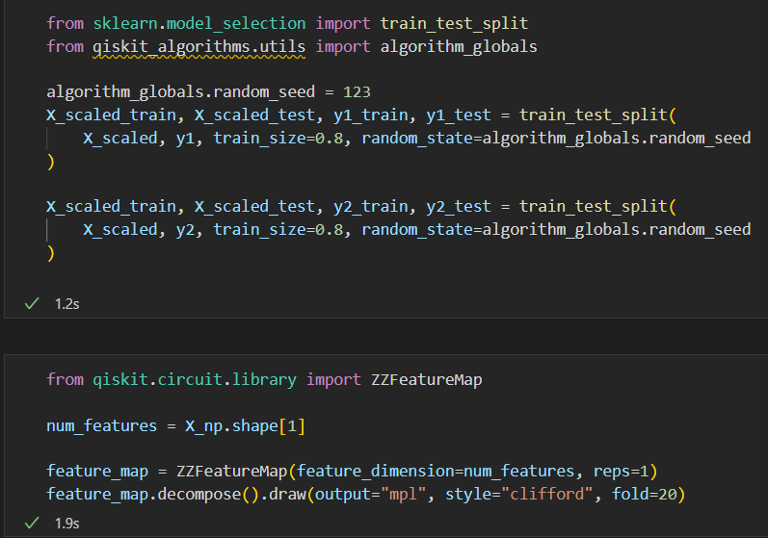

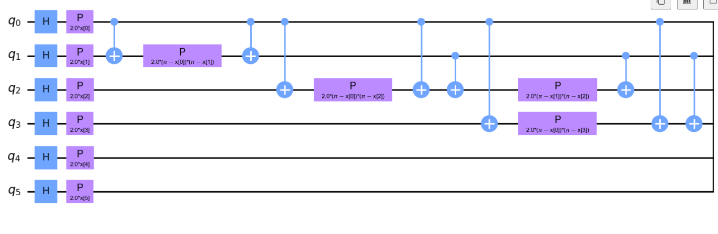

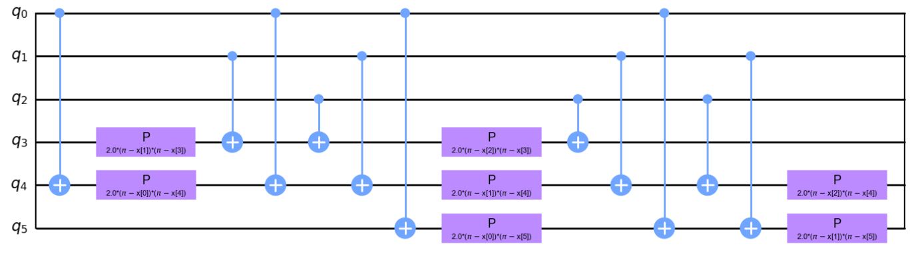

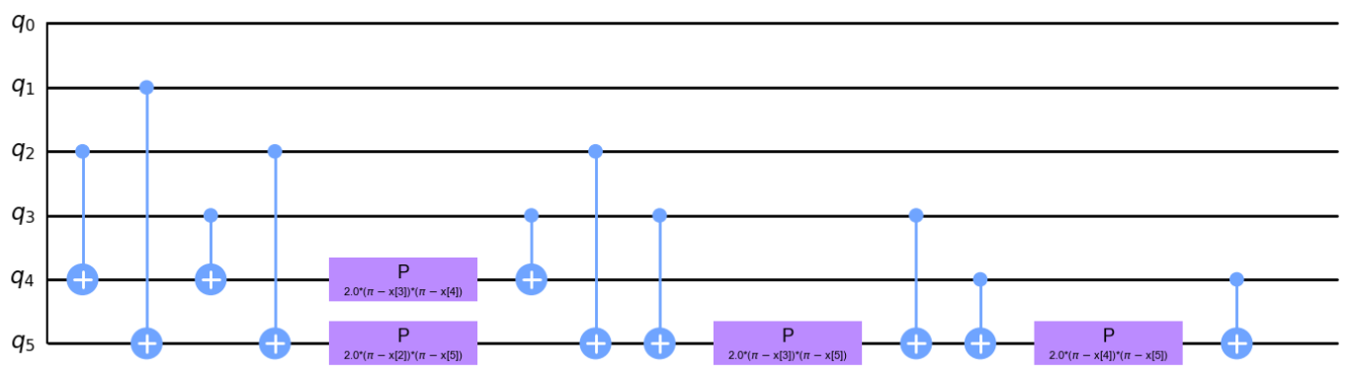

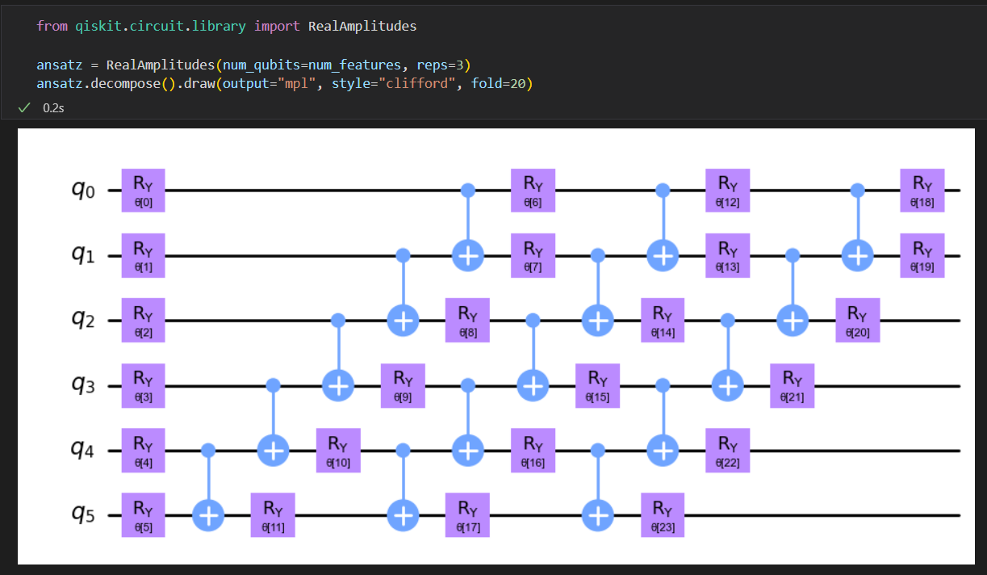

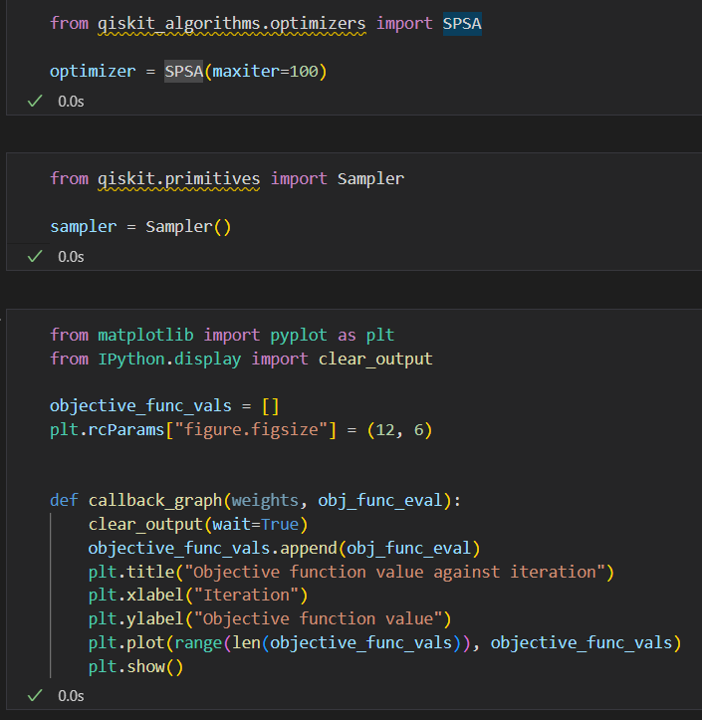

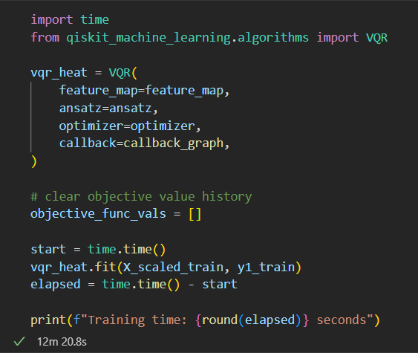

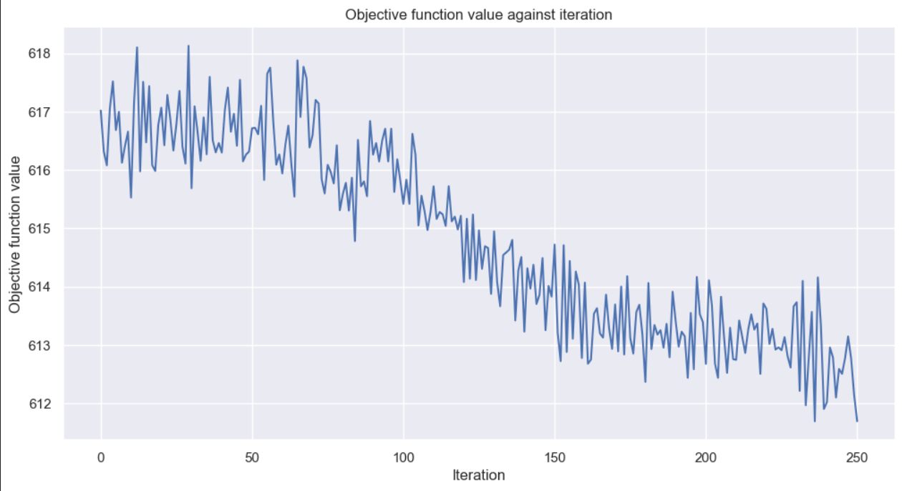

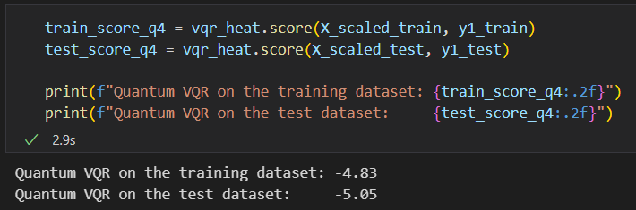

* **CONCLUSION**

This project demonstrates the potential and challenges of using quantum machine learning for energy efficiency prediction. By leveraging a quantum neural network with a customized feature map and variational ansatz, we explored a novel approach to predicting heating and cooling loads based on building features. Although still in its infancy, quantum computing introduces unique capabilities, such as leveraging entanglement and superposition, which classical models cannot replicate directly.

However, the project also highlighted current limitations. The implementation required numerous adjustments due to evolving quantum libraries, and the computational performance was constrained by available quantum simulators. Practical application of quantum machine learning remains limited to small datasets and simple architectures due to resource constraints and the noise in current quantum hardware.

Despite these challenges, this project shows that as quantum hardware and libraries mature, quantum-enhanced machine learning could become a valuable tool in complex predictive tasks like energy efficiency. Future work could focus on hybrid models that combine quantum and classical components to overcome current quantum hardware limitations, providing a stepping stone toward real-world applications of quantum machine learning in energy analytics and beyond.

* **APPLICATIONS**
* Smart Grid Optimisation
* Energy Efficient Supply Chain and Logistics
* Renewable Energy Integration
* Data Centre Energy Optimisation
* Energy Efficient Transport and Routing

**X. ADVANTAGES**

* Optimized Energy Usage and Cost Savings
* Handling Complex, High-dimensional Problems
* Reduced Carbon Footprint
* Longer Lifespan of Equipment
* Energy-efficient Charging and Storage

**XI. FUTURE VISION**

As we will continue to progress in the field of Quantum machine learning we will definitely invent better algorithms that help in optimization this well help us to control energy usage on a very large scale maybe regulating the energy flow of huge cities this will lead to the following things

* Optimized Energy Generation
* Better Resource location
* In general upgrade in quality and working of equipment
* Enhancement in decision making and predictive models